Batch: B2 Roll No.: 1611103
Experiment No. 1
Grade: AA / AB / BB / BC / CC / CD /DD

Title: Implementation of different operations on linked list – insertion, deletion, display

Objective: To create a linked-List and perform basic operations such as insertion , deletion on nodes and display the final list on it.

Expected Outcome of Experiment:

CO | Outcome
2 | Use linear and non-linear data structure in domain like compiler  construction, DBMS etc

Books/ Journals/ Websites referred:

- https://en.wikipedia.org/wiki/Linked_list#Singly_linked_list

- https://www.google.co.in/url?sa=t&rct=j&q=&esrc=s&source=web&cd=11&cad=rja&uact=8&ved=0ahUKEwie5c_Ns7HVAhUCR48KHV-dAAwQtwIIXzAK&url=https%3A%2F%2Fwww.youtube.com%2Fwatch%3Fv%3DbpHWYdx74jo&usg=AFQjCNGvwAXix1PWSRqwp16B5Q3LEjtyHg

Abstract:-
(1) Created a linked list.
(2) Inserted an element at given position.
(3) Deleted a given element.
(4) Display of linked list after any operations.
Linked List is a linear data structure and it is very common data structure
which consists of group of nodes in a sequence which is divided in two parts. Each
node consists of its own data and the address of the next node and forms a chain.
Linked Lists are used to create trees and graphs

Related Theory: -
A linked list, in simple terms, is a linear collection of data
elements. These data elements are called nodes. Linked lists is a data structure
which in turn can be used to implement other data structures. It acts as a building
block to implement data structures such as stacks queues and their variations. It
can be perceived as a train of sequence of nodes in which each node contains one
or more data fields and a pointer to the next node.

Different types of linked list :-

Each record of a linked list is often called an 'element' or ‘node’.
The field of each node that contains the address of the next node is usually called the 'next link' or 'next pointer'. The remaining fields are known as the 'data', 'information', 'value', 'cargo', or 'payload' fields.
The 'head' of a list is its first node. The 'tail' of a list may refer either to the rest of the list after the head, or to the last node in the list. In Lisp and some derived languages, the next node may be called the ‘cdr' (pronounced could-er) of the list, while the payload of the head node may be called the 'car'.

Singly linked list
Singly linked lists contain nodes which have a data field as well as a 'next' field, which points to the next node in line of nodes. Operations that can be performed on singly linked lists include insertion, deletion and traversal.

A singly linked list whose nodes contain two fields: an integer value and a link to the next node

Doubly linked list
In a 'doubly linked list', each node contains, besides the next-node link, a second link field pointing to the 'previous' node in the sequence. The two links may be called 'forward('s') and 'backwards', or 'next' and 'prev'('previous').
A doubly linked list whose nodes contain three fields: an integer value, the link forward to the next node, and the link backward to the previous node
A technique known as XOR-linking allows a doubly linked list to be implemented using a single link field in each node. However, this technique requires the ability to do bit operations on addresses, and therefore may not be available in some high-level languages.
Many modern operating systems use doubly linked lists to maintain references to active processes, threads, and other dynamic objects.^{[2]} A common strategy for rootkits to evade detection is to unlink themselves from these lists.^{[3]}

Multiply linked list
In a 'multiply linked list', each node contains two or more link fields, each field being used to connect the same set of data records in a different order (e.g., by name, by department, by date of birth, etc.). While doubly linked lists can be seen as special cases of multiply linked list, the fact that the two orders are opposite to each other leads to simpler and more efficient algorithms, so they are usually treated as a separate case.

Circular Linked list
In the last node of a list, the link field often contains a null reference, a special value used to indicate the lack of further nodes. A less common convention is to make it point to the first node of the list; in that case the list is said to be 'circular' or 'circularly linked'; otherwise it is said to be 'open' or 'linear'.
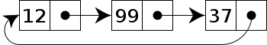
A circular linked list
In the case of a circular doubly linked list, the only change that occurs is that the end, or "tail", of the said list is linked back to the front, or "head", of the list and vice versa.

Sentinel nodes
In some implementations an extra 'sentinel' or 'dummy' node may be added before the first data record or after the last one. This convention simplifies and accelerates some list-handling algorithms, by ensuring that all links can be safely dereferenced and that every list (even one that contains no data elements) always has a "first" and "last" node.

Empty lists
An empty list is a list that contains no data records. This is usually the same as saying that it has zero nodes. If sentinel nodes are being used, the list is usually said to be empty when it has only sentinel nodes.

Hash linking
The link fields need not be physically part of the nodes. If the data records are stored in an array and referenced by their indices, the link field may be stored in a separate array with the same indices as the data records.

List handles
Since a reference to the first node gives access to the whole list, that reference is often called the 'address', 'pointer', or 'handle' of the list. Algorithms that manipulate linked lists usually get such handles to the input lists and return the handles to the resulting lists. In fact, in the context of such algorithms, the word "list" often means "list handle". In some situations, however, it may be convenient to refer to a list by a handle that consists of two links, pointing to its first and last nodes.

So,
In computer science, a linked list is a linear collection of data elements, in which linear order is not given by their physical placement in memory. Each pointing to next node by means of a pointer . It is a data structure consisting of a group of nodes which together represent a sequence. Under the simplest form, each node is composed of data and a reference (in other words, a link) to the next node in the sequence. This structure allows for efficient insertion or removal of elements from any position in the sequence during iteration. More complex variants add additional links, allowing efficient insertion or removal from arbitrary element references.
A linked list whose nodes contain two fields: an integer value and a link to the next node. The last node is linked to a terminator used to signify the end of the list.
Linked lists are among the simplest and most common data structures. They can be used to implement several other common abstract data-types, including lists (the abstract data type), stacks, queues, associative arrays, and S-expressions, though it is not uncommon to implement the other data structures directly without using a list as the basis of implementation.
The principal benefit of a linked list over a conventional array is that the list elements can easily be inserted or removed without reallocation or reorganization of the entire structure because the data items need not be stored contiguously in memory or on disk, while an array has to be declared in the source code, before compiling and running the program. Linked lists allow insertion and removal of nodes at any point in the list, and can do so with a constant number of operations if the link previous to the link being added or removed is maintained during list traversal.
On the other hand, simple linked lists by themselves do not allow random access to the data, or any form of efficient indexing. Thus, many basic operations — such as obtaining the last node of the list (assuming that the last node is not maintained as separate node reference in the list structure), or finding a node that contains a given datum, or locating the place where a new node should be inserted — may require sequential scanning of most or all of the list elements. The advantages and disadvantages of using linked lists are given below.

Implementation Details:
1. Enlist all the Steps followed and various options explored
2. Explain your program logic, classes and methods used.
3. Explain the Importance of the approach followed by you

ANSWERS :-

(1)

The various steps needed to be followed for performing operations on linked list
are:
1. Creating a linked list:
struct node {
int data;
struct node *next;
};
It contains a pointer variable START which stores address of the first node of the
list. We can traverse entire list using start.

2. Traversing the list:

For traversing the list we needanother pointer variable HEAD which points to the
node that is currently being accessed.

3. Inserting a new node at a given position:

We first traverse the list to the node before the position to be entered in. Then
with the help of a temporary node we insert the node in the position asked.

4. Deletion of the node:

The user enters the value to be deleted and then we search for the value
throughout the list. After finding the value we first connect the nodes before and
after the one to be deleted and then free the memory of the node to be deleted.

5. Display:

The data in the linked list is displayed in a sequencial order by traversing the list
and printing the intermediate values.

6. Exit:
The user exits from the program.

(2)
Logic used:

Before creating any node, memory should be allocated to the node dynamically before entering any value in it. During deletion the same memory must be freed to prevent memory leakage.

Using the same logic the list is created by moving the position of head from start to next till the value is not NULL. At the same time data is stored in it.

printf("\n Enter the data: ");
scanf("%d", &num);
while(num! = 1)
{
new_node = (node*)malloc(sizeof (node));
new_node ->data=num;
if(start == NULL){
new_node->next=NULL;
start = new_node;
}
else{
head=start;
while(head->next!=NULL){
head=head->next;
}
head->next = new_node;
new_node->next=NULL;
}
printf("\n Enter the data: ");
scanf("%d", &num);
}
return start;

NOW,

Displaying the list can be done by traversing the list.

node *display(node *start){
node *head;
head=start;
while(head!=NULL){
printf("\t %d", head->data);
head=head->next;
}
return start;

NOW,

For inserting a node we use a temporary node called PREHEAD for storing the previous node. After we reach the position of insertion, we change the next pointers in such a way that new node is inserted at its position.

node *insert(node *start){
node *new_node, *head, *prehead;
int num, val,count=0;
printf("\n Enter the data: ");
scanf("%d",&num);
printf("\n Enter the position at which the data is to be inserted: ");
scanf("%d",&val);
new_node=(node*)malloc(sizeof(node));
new_node->data=num;
head=start;
while(count!=(val-1)){
prehead=head;
head=head->next;
count++;
}
prehead->next=new_node;
new_node->next=head;
return start;
}

NOW,

For deletion we search for the value to be deleted. Once we find it using a while loop, we use the temporary variable PREHEAD adjust NEXT pointer values so node to be deleted is skipped . Then we free the memory of the deleted node.

node *delete_node(node *start){
node *head, *prehead;
int val;
printf("\n Enter the value of the node that has to be deleted: ");
scanf("%d",&val);
head=start;
if(head->data==val){
start=start->next;
free(head);
return start;
}
else{
while(head->data!=val){
prehead=head;
head=head->next;
}
prehead->next=head->next;
free(head);
return start;
}

(3)

ADVANTAGES :-

(#) Linked lists are a dynamic data structure, which can grow and be pruned, allocating and de-allocating memory while the program is running.
(#) Insertion and deletion node operations are easily implemented in a linked list.
(#) Dynamic data structures such as stacks and queues can be implemented using a linked list.
(#) There is no need to define an initial size for a linked list.
(#) Items can be added or removed from the middle of list.
(#) Backtracking is possible in two way linked list.
ADVANTAGES OF LINKED-LIST OVER ARRAY :-

Both Arrays and Linked-list can be used to store linear data of similar types, but they both have some advantages and disadvantages over each other.
Following are the points in favour of Linked Lists.
(1) The size of the arrays is fixed: So we must know the upper limit on the number of elements in advance. Also, generally, the allocated memory is equal to the upper limit irrespective of the usage, and in practical uses, upper limit is rarely reached.
(2) Inserting a new element in an array of elements is expensive, because room has to be created for the new elements and to create room existing elements have to shifted.
For example, suppose we maintain a sorted list of IDs in an array id[].
id[] = [1000, 1010, 1050, 2000, 2040, …..].
And if we want to insert a new ID 1005, then to maintain the sorted order, we have to move all the elements after 1000 (excluding 1000).
Deletion is also expensive with arrays until unless some special techniques are used. For example, to delete 1010 in id[], everything after 1010 has to be moved.
So Linked list provides following two advantages over arrays
1) Dynamic size
2) Ease of insertion/deletion

IMPLEMENTATION DETAILS:

#include<stdio.h>
#include<conio.h>
#include<stdlib.h>
typedef struct node
{
int ele;
struct node *next;
}n;
void createLL(n **n1,int x)
{
if(x > 0)
{
*n1 = (n *)malloc(sizeof(n));
printf("Enter Data : ");
scanf("%d",&(*n1)->ele);
createLL(&(*n1)->next,x-1);
}
else
{
*n1 = NULL;
printf("List created succesfully!!!!\n");
return;
}
}
void prntLL(n *n2)
{
if(n2 != NULL)
{
printf("%d",n2->ele);
if(n2->next!=NULL)
{
printf("--->");
prntLL(n2->next);
}

}
return;
}
void insrtSort(n **n3,int e)
{
n *temp = *n3,*ptr;
if(temp == NULL || temp->ele >= e)
{
ptr = (n *)malloc(sizeof(n));
ptr->ele =e;
ptr->next = temp;
temp = ptr;
*n3 = temp;
}
else
{
while(temp->next!=NULL && temp->next->ele < e)
{
temp = temp->next;
}
ptr = (n *)malloc(sizeof(n));
ptr->ele = e;
ptr->next = temp->next;
temp->next = ptr;
}
}
int countL(n *ele)
{
int c = 0;n *cur = ele;
while(cur!=NULL)
{
c++;
cur = cur->next;
}
return c;
}
n *reverse(n *head)
{
n *temp,*nw,*start = NULL;
temp = head;
while(temp!=NULL)
{
nw = (n *)malloc(sizeof(n));
nw->ele = temp->ele;
nw->next = start;
start = nw;
temp = temp->next;
}
return start;
}
void del(n **n4)
{
int e;
printf("Enter the element to delete : ");
scanf("%d",&e);
n *temp= *n4,*ptr;
if(temp->ele == e)
{
ptr = temp;
temp = ptr->next;
free(ptr);
*n4 = temp;
}
else
{
while(temp->next!=NULL && temp->next->ele !=e)
temp = temp->next;
if(temp->next == NULL &&temp->next->ele != e)
printf("Element does not exist!\n");
else
{
ptr = temp->next;
temp->next = ptr->next;
free(ptr);
}
}
}
void concat(n **head1,n **head2)
{
//int l = countL(head2);
n *temp = *head2;
while(temp!=NULL)
{
insrtSort(head1,temp->ele);
temp = temp->next;
}
}
void main()
{
clrscr();
n *head1 = NULL,*head2 = NULL;
printf("Enter the total elements of list 1 : ");
int i = 0,x,e;
scanf("%d",&x);
//createLL(&head,x);
for(;i<x;i++) //for creating ll
{
printf("Enter the element : ");
scanf("%d",&e);
insrtSort(&head1,e);
}
printf("Enter the total elements of list 2 : ");
scanf("%d",&x);
for(i = 0;i<x;i++) //for creating ll
{
printf("Enter the element : ");
scanf("%d",&e);
insrtSort(&head2,e);
}
int option = -1;
do
{
printf("Entering menu.Press any key to continue.!!");
getch();
clrscr();
printf("****MAIN MENU****\n");
printf("1.Insert(List 1)\n2.Insert(List 2)\n");
printf("3.Delete(List 1)\n4.Delete(List 2)\n5.Concatenation\n");
printf("6.Reverse(List 1)\n7.Reverse(List 2)\n8.Display\n9.Count\n10.Exit\n");
scanf("%d",&option);
switch(option)
{
case 1:
printf("Enter the value to insert : ");
scanf("%d",&e);
insrtSort(&head1,e);
break;
case 2:
printf("Enter the value to insert : ");
scanf("%d",&e);
insrtSort(&head2,e);
break;
case 3:
del(&head1);
break;
case 4:
del(&head2);
break;
case 6:
head1 = reverse(head1);
break;
case 7:
head2 = reverse(head2);
break;
case 8:
printf("List 1 : \n");
prntLL(head1);
printf("\nList 2 : \n");
prntLL(head2);
printf("\n");
break;
case 10 : break;
case 5:
printf("Performing sorted concantenation.....\n");
concat(&head1,&head2);
break;
case 9: printf("No. of elements of.....\n");
printf("List 1 are : %d\n",countL(head1));
printf("List 2 are : %d\n",countL(head2));
break;
default:printf("Error.Try Again!!");
}
}while(option!=10);
getch();
}

OUTPUT:-

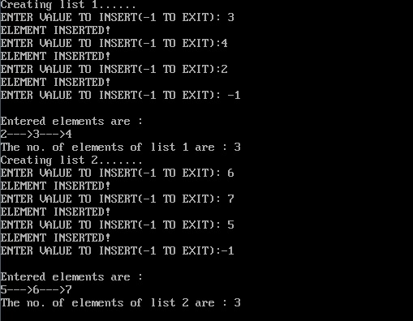
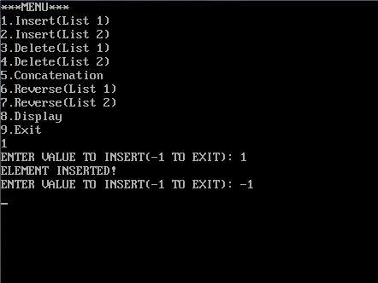
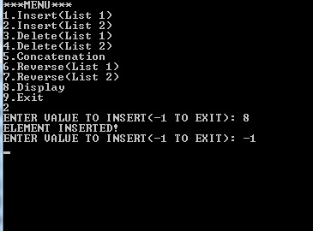

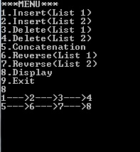
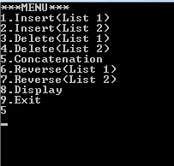
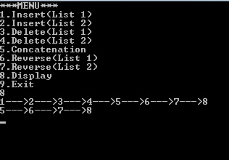
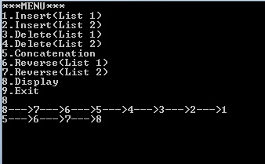
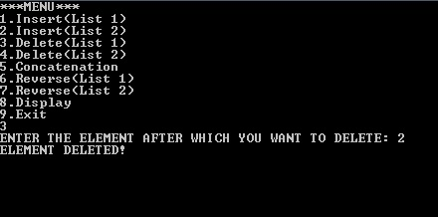
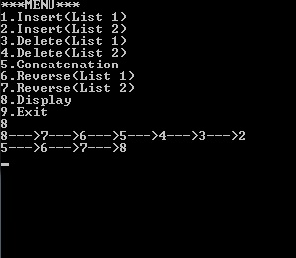

Conclusion:-
Thus, the different operations on the linked list have been successfully implemented.

